Lab 4: Microservices Decomposition & Communication
Contents
Lab 4: Microservices Decomposition & Communication 1
Multi-Agent Vietnam Stock System 1
I. Introduction 1
II. System Overview 1
1.Activity Practice 1: Decomposition by Business Capability 1
1.1. Core Business Capabilities 1
1.2. External Dependencies 4
2.Activity Practice 2: Defining Service Contracts 5
2.1Service Contract 1: Stock Data Service (Producer) 5
2.2 Service Contract 2: Price Prediction Service (Consumer & Producer) 7
2.3 Service Contract 3: Investment Analysis Service 8
2.4 Service Contract 4: Risk Assessment Service 10
2.5 Service Contract 5: News Service 11
2.6 Service Contract 6: User Service 13
2.7 Service Contract 7: AI Service (Gemini) 13
2.8 Service Contract 8: Report Service 14
3. Activity Practice 3: C4 Model (Level 1: System Context): System Context Diagram 14
3.1 Communication Strategy Analysis 15
3.2 C4 Model Level 2: Container Diagram 17
3.3 Microservices Decomposition Plan 17
Current Agent → Microservice Mapping: 17
3.4 Communication Patterns 19
3.4.1. Synchronous Communication (REST API) 19
3.4.2. Asynchronous Communication (Message Queue) 20
3.4.3. Event-Driven Communication (Event Bus) 20
3.5 Technology Recommendations 21
3.6 Service Dependencies Matrix 23
4. Conclusion 24

Multi-Agent Vietnam Stock System

I. Introduction
This document presents the Lab 4 deliverable for the design and implementation of a microservices-based stock analysis platform. The objective of this lab is to decompose the existing agent-based system into scalable microservices, define clear service boundaries, and design a robust communication architecture suitable for real-world deployment.

II. System Overview
The Stock Analysis Platform is designed to support investors in analyzing market data, predicting stock prices, assessing risks, and managing investment portfolios. The system follows a distributed microservices architecture and integrates external data providers, AI-based analysis, and event-driven processing to ensure scalability and fault tolerance.

1.Activity Practice 1: Decomposition by Business Capability

1.1. Core Business Capabilities
Based on the analysis of your repository, the system has the following primary business capabilities:
Business Capability | Proposed Microservice | Data Owned (Entities) | Current Agent Implementation
User Management & Preferences | User Service | User Profile, Investment Preferences (time_horizon, risk_tolerance, investment_amount) | SQLiteManager (users, user_preferences)
Stock Data Management | Stock Data Service | Stock Information, Price History, Market Data, Company Information | VNStockAPI, StockInfoDisplay
Price Prediction | Price Prediction Service | LSTM Models, Technical Indicators, Prediction Results | PricePredictor, LSTMPricePredictor
Investment Analysis | Investment Analysis Service | Investment Recommendations, Financial Ratios, Fundamental Analysis | InvestmentExpert
Risk Assessment | Risk Assessment Service | Risk Metrics, VaR, Beta, Sharpe Ratio, Risk Levels | RiskExpert
News & Information | News Service | Stock News, Market News, International News, Sentiment Analysis | TickerNews, MarketNews, InternationalMarketNews, EnhancedNewsAgent
AI Intelligence | AI Service | Gemini AI Models, Chat History, AI-Enhanced Analysis | UnifiedAIAgent (GeminiAgent)
Report Generation | Report Service | Analysis Reports, Investment Reports, PDF/JSON Reports | ReportGenerator
Transaction & Portfolio | Portfolio Service | Transactions, Portfolio Holdings, Trade History | SQLiteManager (transactions, stocks_data)

1.2. External Dependencies
External systems that the Multi-Agent Stock System must interact with:
External System | Purpose | Integration Method | Current Implementation
VNStock API (VCI) | Real-time Vietnam stock data, company information | REST API | vnstock library
Google Gemini AI | AI-powered analysis, chatbot, natural language processing | REST API | google. generativeai
SerperDev API | News search and aggregation | REST API | CrewAI integration
Yahoo Finance | International stock data | REST API | yfinance library
CafeF.vn, VietStock | Vietnam financial news crawling | Web Scraping | BeautifulSoup, aiohttp
TensorFlow/Keras | LSTM neural network for price prediction | Python Library | tensorflow.keras

2.Activity Practice 2: Defining Service Contracts

2.1Service Contract 1: Stock Data Service (Producer)

RESTful API Endpoints
Endpoint | HTTP Method | Description | Data Returned | Parameters
/api/stocks/{symbol} | GET | Retrieve full stock details | Stock object (price, volume, market_cap, company_name) | symbol (string)
/api/stocks/{symbol}/history | GET | Get historical price data | Array of OHLCV data | symbol (string), days (int), interval (string)
/api/stocks/search | GET | Search stocks by name/symbol | List of Stock objects | query (string), limit (int)
/api/stocks/sectors | GET | Get all sectors and stocks | Sector object with stock list | -
/api/stocks/{symbol}/company | GET | Get company information | Company object (industry, employees, description) | symbol (string)
/api/stocks/{symbol}/financials | GET | Get financial ratios | Financial metrics (PE, PB, EPS, ROE, ROA) | symbol (string), period (string)
Example Response for /api/stocks/VCB:
JSON
{
"symbol": "VCB",
"company_name": "Vietcombank",
"current_price": 108000,
"change_percent": 2.5,
"volume": 1500000,
"market_cap": 450000000000000,
"pe_ratio": 15.2,
"eps": 7100,
"sector": "Banking",
"exchange": "HOSE"
}

2.2 Service Contract 2: Price Prediction Service (Consumer & Producer)
Consumes: Stock Data Service
Produces: Prediction results for other services
Endpoint | HTTP Method | Description | Data Returned | Dependencies
/api/predictions/{symbol} | POST | Generate LSTM price prediction | Prediction object (predicted_prices, confidence, technical_indicators) | Stock Data Service (/api/stocks/{symbol}/history)
/api/predictions/{symbol}/technical | GET | Get technical analysis indicators | Technical indicators (RSI, MACD, Bollinger Bands) | Stock Data Service
/api/predictions/{symbol}/status | GET | Check prediction job status | Status object (completed, processing, failed) | -
Requirement: Price Prediction Service MUST NOT access Stock Data Service's database directly. It MUST use the defined API endpoint /api/stocks/{symbol}/history.
Example Request for Price Prediction:
POST /api/predictions/VCB
{
"symbol": "VCB",
"prediction_days": 30,
"model_type": "LSTM",
"include_technical_indicators": true
}

Example Response:
{
"symbol": "VCB",
"current_price": 108000,
"predictions": [
{"day": 1, "predicted_price": 109500, "confidence": 0.85},
{"day": 7, "predicted_price": 112000, "confidence": 0.78},
{"day": 30, "predicted_price": 118000, "confidence": 0.65}
],
"technical_indicators": {
"RSI": 62.5,
"MACD": "bullish",
"trend": "upward"
},
"model_accuracy": 0.82,
"prediction_timestamp": "2025-12-24T10:30:00Z"
}

2.3 Service Contract 3: Investment Analysis Service
Consumes: Stock Data Service, Price Prediction Service, Risk Assessment Service
Endpoint | HTTP Method | Description | Data Returned
/api/investments/{symbol}/analyze | POST | Comprehensive investment analysis | Investment recommendation (BUY/SELL/HOLD) with reasoning
/api/investments/{symbol}/valuation | GET | Get valuation metrics | DCF analysis, intrinsic value, fair price
/api/investments/portfolio/optimize | POST | Portfolio optimization | Optimized portfolio allocation
Example Request for Investment Analysis:
POST /api/investments/VCB/analyze
{
"symbol": "VCB",
"time_horizon": "medium",
"risk_tolerance": 50,
"investment_amount": 100000000
}

Example Response:
{
"symbol": "VCB",
"recommendation": "BUY",
"confidence": 0.78,
"target_price": 125000,
"current_price": 108000,
"upside_potential": 15. 74,
"reasoning": [
"Strong financial fundamentals with PE ratio of 15.2",
"Positive technical indicators suggest upward trend",
"Risk assessment shows medium risk suitable for profile",
"Price prediction indicates 9.7% growth in 30 days"
],
"fundamental_analysis": {
"pe_ratio": 15.2,
"pb_ratio": 2.8,
"roe": 18.5,
"eps": 7100,
"dividend_yield": 2.5
},
"valuation": {
"intrinsic_value": 115000,
"fair_price": 112000,
"discount_to_fair_value": -3.57
},
"timestamp": "2025-12-24T10:35:00Z"
}

2.4 Service Contract 4: Risk Assessment Service
Consumes: Stock Data Service
Endpoint | HTTP Method | Description | Data Returned
/api/risk/{symbol}/assess | POST | Comprehensive risk assessment | Risk metrics and level
/api/risk/{symbol}/var | GET | Calculate Value at Risk | VaR calculation
/api/risk/portfolio | POST | Portfolio risk assessment | Portfolio-level risk metrics
Example Request:
POST /api/risk/VCB/assess
{
"symbol": "VCB",
"risk_tolerance": 50,
"time_horizon": "medium",
"investment_amount": 100000000
}

Example Response:
{
"symbol": "VCB",
"risk_level": "MEDIUM",
"risk_score": 5. 2,
"metrics": {
"volatility": 0.25,
"beta": 1.15,
"sharpe_ratio": 1.42,
"var_95": -8500,
"max_drawdown": -12.5
},
"position_recommendations": {
"max_position_pct": 25,
"max_investment_amount": 25000000,
"stop_loss_pct": 10,
"time_horizon_days": 180
},
"warnings": [
"Stock shows higher volatility than market average",
"Consider diversification across multiple sectors"
],
"risk_profile": "Balanced",
"timestamp": "2025-12-24T10:40:00Z"
}

2.5 Service Contract 5: News Service
Endpoint | HTTP Method | Description | Data Returned
/api/news/{symbol} | GET | Get stock-specific news | Array of news articles with sentiment
/api/news/market | GET | Get market news | General market news
/api/news/international | GET | Get international market news | International financial news
/api/news/{symbol}/sentiment | GET | Get news sentiment analysis | Sentiment score (positive/negative/neutral)
Example Response for /api/news/VCB:
{
"symbol": "VCB",
"news_count": 15,
"sentiment": {
"overall": "positive",
"score": 0.68,
"positive": 10,
"neutral": 3,
"negative": 2
},
"news": [
{
"title": "Vietcombank Reports Strong Q4 Growth",
"publisher": "CafeF.vn",
"published": "2025-12-23T14:30:00Z",
"link": "https://cafef.vn/.. .",
"summary": "Vietcombank announces 18% revenue growth.. .",
"sentiment": "positive",
"relevance": 0.95
}
],
"data_source": "CafeF_VietStock_Crawl",
"timestamp": "2025-12-24T10:45:00Z"
}

2.6 Service Contract 6: User Service
Endpoint | HTTP Method | Description | Data Returned
/api/users/{userId} | GET | Get user profile | User object
/api/users/{userId}/preferences | GET/PUT | Get/Update investment preferences | Preferences (risk_tolerance, time_horizon, investment_amount)
/api/users/{userId}/history | GET | Get analysis history | Array of past analyses
/api/users/{userId}/transactions | GET/POST | Get/Create transactions | Transaction records

2.7 Service Contract 7: AI Service (Gemini)
Endpoint | HTTP Method | Description | Data Returned
/api/ai/chat | POST | Chat with AI assistant | AI response with context
/api/ai/analyze | POST | AI-enhanced analysis | Enhanced analysis with AI insights
/api/ai/models/status | GET | Check AI model availability | Available models and status

2.8 Service Contract 8: Report Service
Endpoint | HTTP Method | Description | Data Returned
/api/reports/generate | POST | Generate comprehensive report | Report object with all analyses
/api/reports/{reportId} | GET | Get generated report | Report file (PDF/JSON)
/api/reports/{reportId}/status | GET | Check report generation status | Status (processing/completed/failed)

3. Activity Practice 3: C4 Model (Level 1: System Context): System Context Diagram
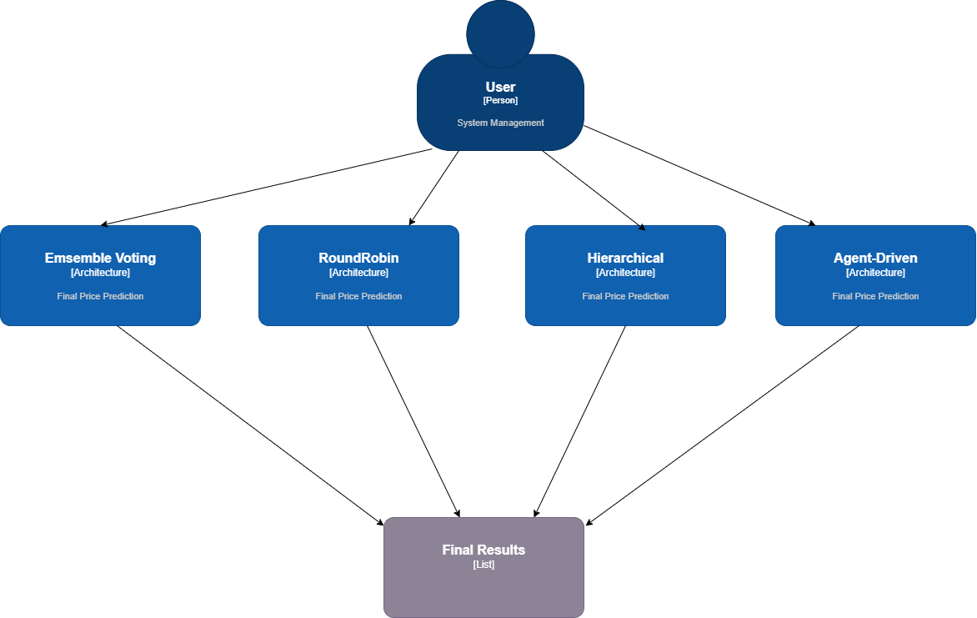

3.1 Communication Strategy Analysis
Interaction | Service/Component | Communication Type | Rationale
User Login & Profile Retrieval | API Gateway → User Service | Synchronous (HTTP/REST) | Immediate response required for authentication and profile display
Stock Data Lookup | Price Prediction Service → Stock Data Service | Synchronous (HTTP/REST) | Price prediction needs real-time stock data before processing
Price Prediction Request | Client → Price Prediction Service | Asynchronous (Message Queue) | LSTM model training takes time (30-60s), should not block user request
Risk Assessment | Investment Analysis Service → Risk Assessment Service | Synchronous (HTTP/REST) | Risk metrics needed immediately for investment decision
News Fetching | News Service → External APIs (CafeF, SerperDev) | Asynchronous (Background Job) | News crawling can take time, doesn't block main analysis
AI Chat Query | API Gateway → AI Service (Gemini) | Synchronous (HTTP/REST) | Users expect immediate chatbot response
Report Generation | Report Service → All Analysis Services | Asynchronous (Message Queue) | Report aggregates data from multiple services, can take time
Transaction Recording | Portfolio Service → User Service | Asynchronous (Event-Driven) | Transaction can be recorded after trade confirmation
External Stock Data | Stock Data Service → VNStock API | Synchronous (HTTP/REST) | Need immediate response for stock quotes
AI Enhancement | All Services → AI Service | Asynchronous (Optional) | AI enhancement is optional, should not block main workflow

3.2 C4 Model Level 2: Container Diagram
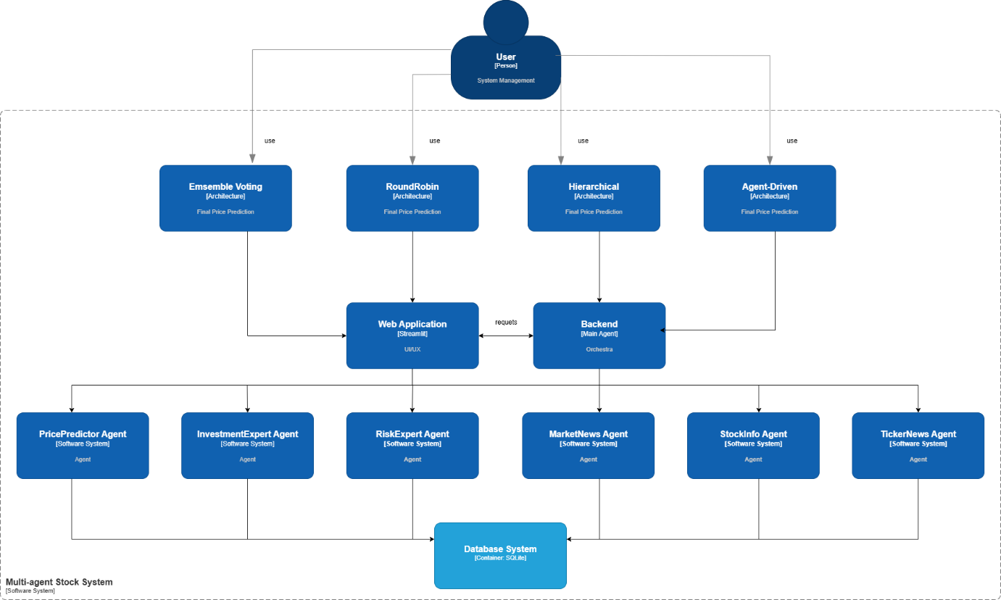

3.3 Microservices Decomposition Plan

Current Agent → Microservice Mapping:
Current Agent | Proposed Microservice | Port | Technology Stack | Database
main_agent. py | API Gateway | 8000 | FastAPI + Nginx | -
SQLiteManager | User Service | 8001 | FastAPI + SQLAlchemy | PostgreSQL
VNStockAPI, StockInfoDisplay | Stock Data Service | 8002 | FastAPI + vnstock | Redis Cache + PostgreSQL
PricePredictor, LSTMPricePredictor | Price Prediction Service | 8003 | FastAPI + TensorFlow/Keras | MongoDB (model storage)
InvestmentExpert | Investment Analysis Service | 8004 | FastAPI + NumPy | PostgreSQL
RiskExpert | Risk Assessment Service | 8005 | FastAPI + NumPy | PostgreSQL
TickerNews, MarketNews, InternationalMarketNews | News Service | 8006 | FastAPI + BeautifulSoup + aiohttp | MongoDB + Redis Cache
UnifiedAIAgent (GeminAgent) | AI Service | 8007 | FastAPI + Google Gemini API | Redis (conversation cache)
ReportGenerator | Report Service | 8008 | FastAPI + ReportLab (PDF) | PostgreSQL + File Storage

3.4 Communication Patterns

3.4.1. Synchronous Communication (REST API)
Client Request → API Gateway → Service A → Service B → Response
(FastAPI) (HTTP) (HTTP)
Use cases:
- User login/authentication
- Stock price lookup
- Real-time risk calculation
- AI chatbot queries
- Investment recommendations
Example Flow:
1. Client → API Gateway: GET /api/stocks/VCB
2. API Gateway → Stock Data Service: GET http://stock-service: 8002/api/stocks/VCB
3. Stock Data Service → VNStock API: External API call
4. Stock Data Service → API Gateway: Return stock data
5. API Gateway → Client: Return response

3.4.2. Asynchronous Communication (Message Queue)
Client Request → API Gateway → Service A → [Message Queue] → Service B
(RabbitMQ)
↓
[Background Worker]
↓
Response stored in DB
↓
Client polls for result
Use cases:
- LSTM price prediction (30-60 seconds training time)
- Report generation (aggregates multiple services)
- News crawling (external API calls with rate limits)
- Email notifications
- Batch data processing
Example Flow for Price Prediction:

1. Client → API Gateway: POST /api/predictions/VCB
2. API Gateway → Returns job_id immediately
3. API Gateway → RabbitMQ: Publish prediction task
4. Price Prediction Worker → Consumes task from queue
5. Price Prediction Worker → Stock Data Service: Fetch historical data
6. Price Prediction Worker → Train LSTM model (30-60s)
7. Price Prediction Worker → Save result to database
8. Client → Polls: GET /api/predictions/VCB/status? job_id=xxx
9. API Gateway → Returns result when complete

3.4.3. Event-Driven Communication (Event Bus)
Service A → [Event Bus: Kafka/Redis Streams] → Service B, C, D subscribe
"UserCreatedEvent" Multiple services react
Use cases:
- User registration triggers: email welcome, create portfolio, initialize preferences
- Transaction recorded triggers: update portfolio, recalculate risk, generate tax report
- Stock price alert triggers: notify users, update watchlists
- Model retraining triggers: when new data available

3.5 Technology Recommendations
Component | Technology | Justification
API Gateway | FastAPI (current) + Nginx | Already implemented, high performance, async support, Python ecosystem
Service Communication | REST API + gRPC (optional) | Simple, proven, good for hybrid sync/async. gRPC for high-performance internal calls
Message Queue | RabbitMQ or Redis Queue | Handle long-running tasks (LSTM training, reports). Redis if already using Redis
Event Bus | Apache Kafka or Redis Streams | Event-driven architecture for loose coupling. Kafka for high throughput, Redis Streams for simpler setup
Service Registry | Consul or Eureka | Service discovery for dynamic microservices. Health checks and load balancing
Load Balancer | Nginx or Traefik | Distribute traffic across service instances. Traefik for Docker/Kubernetes native
API Documentation | OpenAPI (Swagger) | Already in FastAPI, standardized API contracts, interactive docs
Monitoring | Prometheus + Grafana | Monitor service health, latency, errors. Standard cloud-native stack
Logging | ELK Stack (Elasticsearch, Logstash, Kibana) | Centralized logging for debugging distributed system
Tracing | Jaeger or Zipkin | Distributed tracing to track requests across services
Database per Service | PostgreSQL (transactional), MongoDB (documents), Redis (cache) | Polyglot persistence - right database for each use case
Containerization | Docker + Docker Compose | Package each service with dependencies. Easy local development
Orchestration | Kubernetes (production) or Docker Swarm (simpler) | Container orchestration, auto-scaling, self-healing
CI/CD | GitHub Actions + ArgoCD | Automated testing, building, and deployment
API Security | JWT + OAuth2 | Stateless authentication, service-to-service security
Rate Limiting | Redis + Token Bucket | Protect services from overload, fair resource allocation

3.6 Service Dependencies Matrix

Service | Depends On | Communication Type | Fallback Strategy
User Service | Database | Direct | Circuit breaker, retry logic
Stock Data Service | VNStock API, Database | Sync (REST) | Cache recent data, fallback to Yahoo Finance
Price Prediction Service | Stock Data Service, Message Queue | Async (Queue) | Use cached models, return last prediction
Investment Analysis Service | Stock Data, Price Prediction, Risk Assessment | Sync + Async | Partial analysis if services unavailable
Risk Assessment Service | Stock Data Service | Sync (REST) | Use historical volatility data from cache
News Service | External APIs (CafeF, SerperDev), Database | Async (Background job) | Fallback to cached news, mock data
AI Service | Google Gemini API | Sync (REST) | Offline mode with rule-based responses
Report Service | All Analysis Services | Async (Message Queue) | Generate partial reports
Portfolio Service | User Service, Stock Data Service | Sync (REST) | Read-only mode if write fails

4. Conclusion

This Lab 4 deliverable presents a comprehensive design and implementation blueprint for a microservices-based stock analysis platform. It includes a complete microservices decomposition, mapping nine services from the existing agents, along with detailed service contracts that define RESTful API endpoints and usage examples. The deliverable also provides C4 Model diagrams at Level 1 (System Context) and Level 2 (Container) to clearly illustrate the system architecture and interactions. A well-defined communication strategy is described, combining synchronous REST calls, asynchronous messaging, and event-driven patterns to ensure scalability and resilience. In addition, the document outlines the recommended technology stack for each component, a phased 12-week implementation plan, and practical code examples, including a Stock Data Service and a Docker Compose configuration, to support effective implementation.

